Game Design Document

Fill up the following document

1. Write the title of your project.

The DEFENDER

1. What is the goal of the game?

Escaping from the enemies.

1. Write a brief story of your game.

There is an rabbit who is hero and there is an bullet and lion which tries to eat the lion.\

The rabbit has to escape from the both.

1. Which are the playing characters of this game?

* Playing characters are the ones who respond to the user based on the input from the user.
* Cars, monkeys, dinos, wizards, etc., are the playing characters in the game.

|  |  |  |
| --- | --- | --- |
| Number | Character Name | What can this character do? |
| 1 | rabbit | fly |
| 2 |  |  |
| 3 |  |  |
| 4 |  |  |
| 5 |  |  |
| 6 |  |  |
| 7 |  |  |
| 8 |  |  |

1. Which are the Non-Playing Characters of this game?

* Non-Playing characters are the ones that don't have an action or behavior when the user interacts with the game.
* Hurdles, stones, bananas, coins, etc., are non-playing characters in the game.

|  |  |  |
| --- | --- | --- |
| Number | Character Name | What can this character do? |
| 1 | bullet | Kill rabbit |
| 2 | lion | Eat rabbit |
| 3 | tree | Just stands |
| 4 |  |  |
| 5 |  |  |
| 6 |  |  |
| 7 |  |  |
| 8 |  |  |

Draw your imagination of this game. What does this game look like?

* Draw the game either on your computer or on paper.
* Add images of the game scenes to show each of the playing and non-playing characters at least once.

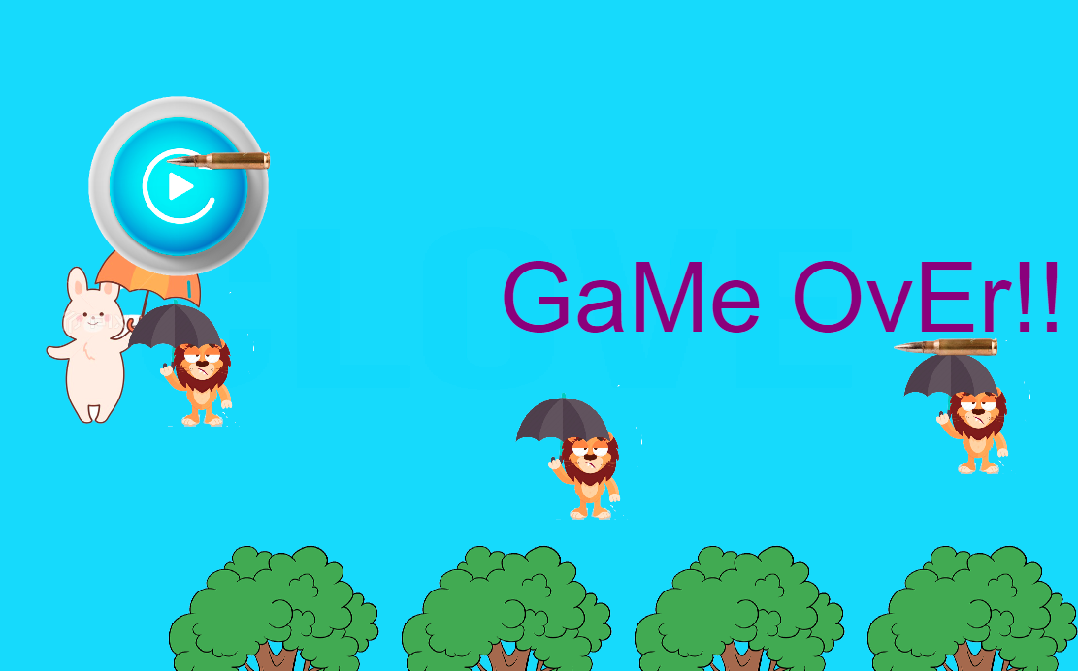

How do you plan to make your game engaging?

The rabbit dies when it is hit by lion on trees or bullets